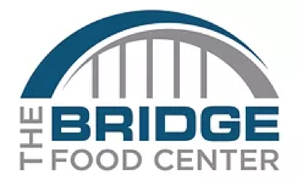  **Bridge Food Center -** Sponsorship Form

**5th Annual Golf Outing - September 19, 2024**

To register: please complete the form below by circling the desired sponsorship level** or go to [www.thebridgemidland.com/golf](http://www.thebridgemidland.com/golf)  to register online:

**see back side for details of recognition for each level

Gold - $5,000 Silver - $2,500 Bronze - $1,000

Hole Sponsor - $500 Coffee & donuts - $250 Beverage Cart - $450

Lunch on Course - $350 Hors d’Oeuvres - $350 Hole Signage - $250

*Name to be printed on signage: ______________________________

Contact Name: ________________________________

Contact E-mail: _______________________________

Contact phone: ________________________________

*Note: Please send company logo (.jpeg format) for signage to thebridgemidland@gmail.com

Payment Method: Payment is handled as part of the online Registration or

Send check payable to The Bridge Food Center (see below)

Please send completed form to: Golf Outing Details:

The Bridge Food Center – Golf Sponsors Thursday, September 19, 2024

1826 S. Saginaw Rd Currie Municipal Golf Course, 1300 Currie Pkwy

Midland, MI 48640 8:00a.m. registration and 9:00a.m. shotgun start

**Gold - $5,000** (event sponsors)

2 Foursomes

Large company sign or banner with name/logo at the registration and moved around to pavilion, etc. (Company to provide sign/banner)

Tee box sign on both front and back courses

Name on Sponsor Board at event and which will be posted at the Bridge after the event

Name on Sponsor Sheet given to every golfer

Shout out at the event opening and closing

Recognition on Facebook and Bridge website

**Silver - $2,500**

Foursome

Company sign with name and logo at the registration (Company to provide sign)

Tee box sign on both front and back courses

Name on Sponsor Board at event and which will be posted at the Bridge after the event

Name on Sponsor Sheet given to every golfer

Shout out at the event opening and closing

**Bronze - $1,000**

Foursome

Tee box sign

Name on Sponsor Board at event and which will be posted at the Bridge after the event

Name on Sponsor Sheet given to every golfer

Shout out at the event opening and closing

**Hole Sponsor - $500**

Foursome

Tee box sign

Name on Sponsor Board at event and which will be posted at the Bridge after the event

Name on Sponsor Sheet given to every golfer

**Other Sponsors**

All sponsors will be listed on a Sponsor Sheet given to every golfer.

Meal sponsors will have signage at their specific meal location.

Drink sponsors will have signage on the beverage cart.